TwentyOne 28 Fitness

Emily Murdoch

Project Deliverable 1 & 2

March 18, 2021

Contents:

Summary ………………………………………………………………………………………………………………………………………………2

Stakeholders …………………………………………………………………………………………………………………………………………2

Glossary ………………………………………………………………………………………………………………………………………………..3

Data Questions ……………………………………………………………………………………………………………………………………..4

Conceptual Model …………………………………………………………………………………………………………………………………5

Logical Model ………………………………………………………………………………………………………………………………………..6

Physical Database Design ………………………………………………………………………………………………………………………7

Summary

TwentyOne 28 Fitness is a new athletic facility that has brought turf fields to the Lansing, Michigan area. The building opened its doors in January, 2021 and are a two-man operation with no way to manage and track their business and data. They currently have a Facebook page and have gained its business through word of mouth as other turf field buildings in the area have closed. Looking at their operation, we are planning to implement a system to track data regarding field usage and rental time, teams, and payments.

Stakeholders

This business consists of two owner, multiple teams that use the fields, multiple team managers, the building owners that have rented the space to the TwentyOne 28 Fitness owners, and the investors that have worked with the business owners to obtain the startup costs necessary for operation. In this database system that we are implementing, we want the team managers to be able to book reservations online, the individual team members given access their schedules, and the TwentyOne 28 Fitness owners able to see the whole building schedule and manage reservations. They should also be able to track business operations, field usage times, teams that are using the space, and profitability.

Business Rules

* A team can play on one field at a time.
* Many teams can be managed by one manager.
* Each manager can make many payments.
* Each payment comes from many invoices.
* A reservation creates an invoice.
* A reservation is held by one team.
* A reservation is for one field.
* A manager can make many reservations.
* A reservation has a cost.
* Field time elapsed influences the cost.

Glossary

* Team – A team consists of a group of young kids playing a sport. Each team has a team name, however multiple teams can have the same name if they are under the same organization, but different age groups.
* Manager – A team manager is the adult person who represents the team in matters of organizing, scheduling, collecting payments, making payments, etc.
* Reservation – A reservation is a time slot on a field that is for one sports team to practice on.
* Field – A field is a large space of turf in the building. Each field has a number, this building has two fields.
* Invoice – An invoice is given to the manager of the team for the costs of the reservation of a field.
* Payment – The payment of the invoice is made by the manager and can be cash, credit, or check.
* Time Elapsed – A reservation’s time slot on the field is the time elapsed for that practice. The cost of the reservation that goes on the invoice depends on the time elapsed.
* Cost – Cost is the monetary value of renting a reservation of a field for a given amount of time.

Data Questions

The type of information we are looking to track with the database and pull out to analyze include the following: the field availability and booking rate, the most common dates and times of reservations, the costs of reservations in relation to operation costs, the number of teams that are reserving fields, the average ages and sizes of the teams, the type of sports that are being played, and the type and consistency of payments being made.

Conceptual Model

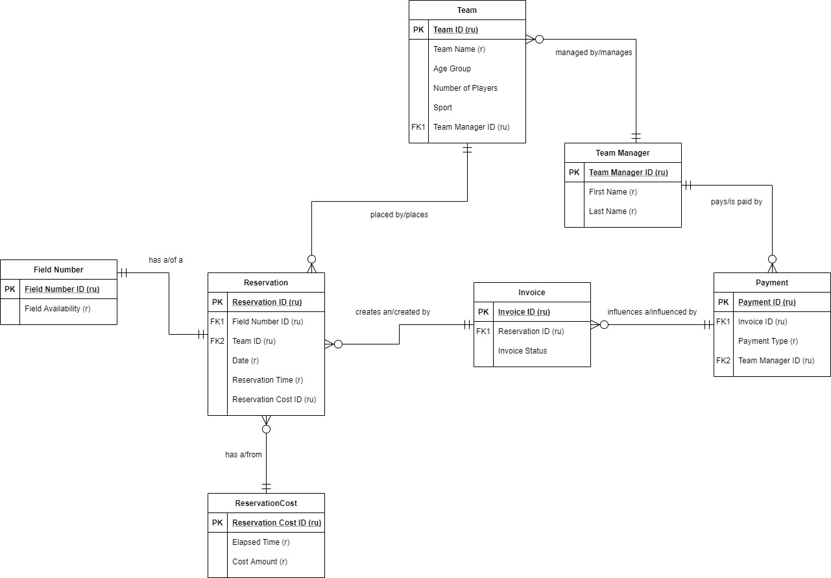

Logical Model

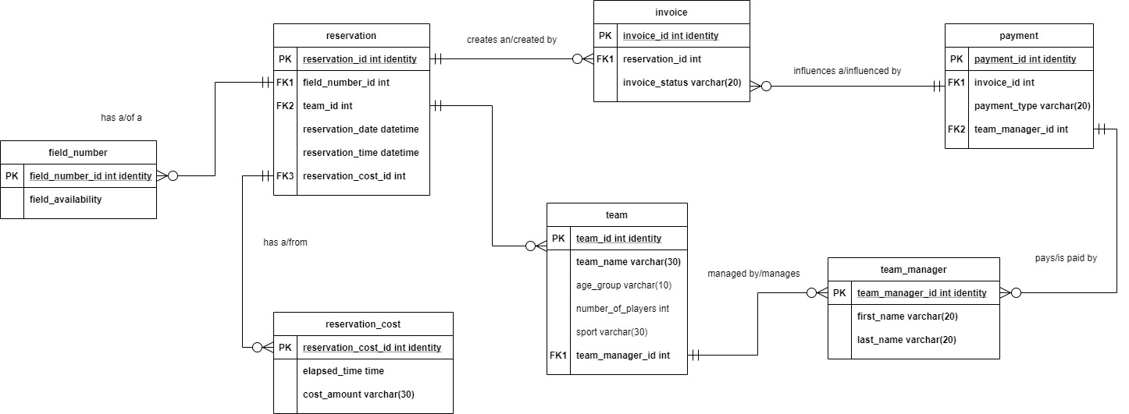

Physical Database Design

-- create tables/views/procedures/functions in repeatable form

-- create drops

-- create drop procedures

IF OBJECT_ID('dbo.spteam') IS NOT NULL

DROP PROCEDURE dbo.spteam

IF OBJECT_ID('dbo.spteammanagers') IS NOT NULL

DROP PROCEDURE dbo.spteammanagers

-- create drop views

IF OBJECT_ID('dbo.Invoices') IS NOT NULL

DROP VIEW dbo.Invoices

IF OBJECT_ID('dbo.TeamReservation') IS NOT NULL

DROP VIEW dbo.TeamReservation

-- create drop tables

IF OBJECT_ID('dbo.payment') IS NOT NULL

DROP TABLE dbo.payment

IF OBJECT_ID('dbo.invoice') IS NOT NULL

DROP TABLE dbo.invoice

IF OBJECT_ID('dbo.reservation') IS NOT NULL

DROP TABLE dbo.reservation

IF OBJECT_ID('dbo.reservation_cost') IS NOT NULL

DROP TABLE dbo.reservation_cost

IF OBJECT_ID('dbo.team') IS NOT NULL

DROP TABLE dbo.team

IF OBJECT_ID('dbo.team_manager') IS NOT NULL

DROP TABLE dbo.team_manager

-- Create database tables

CREATE TABLE team_manager(

--create columns

team_manager_id int identity

, first_name varchar(20) NOT NULL

, last_name varchar(20) NOT NULL

-- place constraints

, CONSTRAINT PK_team_manager PRIMARY KEY(team_manager_id)

)

CREATE TABLE team(

-- create columns

team_id int identity

, team_name varchar(30) NOT NULL

, age_group varchar(10)

, number_of_players int

, sport varchar(30)

, team_manager_id int NOT NULL

-- place constraints

, CONSTRAINT PK_team PRIMARY KEY(team_id)

, CONSTRAINT FK1_team FOREIGN KEY(team_manager_id) REFERENCES team_manager(team_manager_id)

)

CREATE TABLE reservation_cost(

-- create columns

reservation_cost_id int identity

, elapsed_time varchar(20) NOT NULL

, cost_amount varchar(30) NOT NULL

-- place contraints

, CONSTRAINT PK_reservation_cost PRIMARY KEY(reservation_cost_id)

)

CREATE TABLE reservation(

-- create columns

reservation_id int identity

, field_name varchar(20) NOT NULL

, team_id int NOT NULL

, reservation_date datetime NOT NULL

, reservation_time datetime NOT NULL

, reservation_cost_id int NOT NULL

-- place constraints

, CONSTRAINT PK_reservation PRIMARY KEY(reservation_id)

, CONSTRAINT FK1_reservation FOREIGN KEY(team_id) REFERENCES team(team_id)

, CONSTRAINT FK2_reservation FOREIGN KEY(reservation_cost_id) REFERENCES reservation_cost(reservation_cost_id)

)

CREATE TABLE invoice(

-- create columns

invoice_id int identity

, reservation_id int NOT NULL

, invoice_status varchar(30) NOT NULL

-- place constraints

, CONSTRAINT PK_invoice PRIMARY KEY(invoice_id)

, CONSTRAINT FK1_invoice FOREIGN KEY(reservation_id) REFERENCES reservation(reservation_id)

)

CREATE TABLE payment(

-- create columns

payment_id int identity

, invoice_id int NOT NULL

, payment_type varchar(20) NOT NULL

, team_manager_id int NOT NULL

-- place constraints

, CONSTRAINT PK_payment PRIMARY KEY(payment_id)

, CONSTRAINT FK1_payment FOREIGN KEY(invoice_id) REFERENCES invoice(invoice_id)

, CONSTRAINT FK2_payment FOREIGN KEY(team_manager_id) REFERENCES team_manager(team_manager_id)

)

-- Inserting all of the current team managers into the team_manager table

INSERT INTO team_manager(first_name , last_name)

VALUES

('John' , 'Smith')

, ('George' , 'Walker')

, ('Kelly' , 'Pine')

, ('Charles' , 'Bates')

, ('Riley' , 'Weber')

-- check the insert data

SELECT * FROM team_manager

-- Insert all the current team data into the team table

INSERT INTO team(team_name , age_group , number_of_players , sport , team_manager_id)

VALUES

('FC Lansing' , 'U14' , '36' , 'soccer' , (SELECT team_manager_id FROM team_manager WHERE first_name = 'Kelly' AND last_name = 'Pine'))

, ('Tornadoes' , 'U16' , '20' , 'lacrosse' , (SELECT team_manager_id FROM team_manager WHERE first_name = 'Charles' AND last_name = 'Bates'))

, ('Panthers' , 'U12' , '24' , 'flag football' , (SELECT team_manager_id FROM team_manager WHERE first_name = 'John' AND last_name = 'Smith'))

, ('Dynamite FC' , 'U17' , '28' , 'soccer' , (SELECT team_manager_id FROM team_manager WHERE first_name = 'George' AND last_name = 'Walker'))

, ('Blue Crush' , 'U11' , '16' , 'lacrosse' , (SELECT team_manager_id FROM team_manager WHERE first_name = 'Riley' AND last_name = 'Weber'))

-- check the insert data

SELECT * FROM team

-- Insert all the pricing information into reservation_cost table

INSERT INTO reservation_cost(elapsed_time , cost_amount)

VALUES

('30 minutes' , '$75.00')

, ('45 minutes' , '$115.00')

, ('60 minutes' , '$150.00')

, ('90 minutes' , '$225.00')

, ('120 minutes' , '$275.00')

-- check the insert data

SELECT * FROM reservation_cost

-- insert reservations made for one week

-- will insert new reservations for the following week as they are made

INSERT INTO reservation(field_name , team_id , reservation_date , reservation_time , reservation_cost_id)

VALUES

('A' , (SELECT team_id FROM team WHERE team_name = 'Blue Crush') , '3/29/2021' , '5:30 pm' , (SELECT reservation_cost_id FROM reservation_cost

WHERE elapsed_time = '60 minutes'))

, ('A' , (SELECT team_id FROM team WHERE team_name = 'Blue Crush') , '3/31/2021' , '5:30 pm' , (SELECT reservation_cost_id FROM reservation_cost

WHERE elapsed_time = '60 minutes'))

, ('B' , (SELECT team_id FROM team WHERE team_name = 'FC Lansing') , '3/29/2021' , '6:00 pm' , (SELECT reservation_cost_id FROM reservation_cost

WHERE elapsed_time = '90 minutes'))

, ('B' , (SELECT team_id FROM team WHERE team_name = 'FC Lansing') , '3/31/2021' , '6:00 pm' , (SELECT reservation_cost_id FROM reservation_cost

WHERE elapsed_time = '90 minutes'))

, ('B' , (SELECT team_id FROM team WHERE team_name = 'FC Lansing') , '4/02/2021' , '6:00 pm' , (SELECT reservation_cost_id FROM reservation_cost

WHERE elapsed_time = '90 minutes'))

, ('A' , (SELECT team_id FROM team WHERE team_name = 'Panthers') , '3/29/2021' , '7:00 pm' , (SELECT reservation_cost_id FROM reservation_cost

WHERE elapsed_time = '90 minutes'))

, ('A' , (SELECT team_id FROM team WHERE team_name = 'Panthers') , '3/31/2021' , '7:00 pm' , (SELECT reservation_cost_id FROM reservation_cost

WHERE elapsed_time = '90 minutes'))

, ('A' , (SELECT team_id FROM team WHERE team_name = 'Panthers') , '4/02/2021' , '7:00 pm' , (SELECT reservation_cost_id FROM reservation_cost

WHERE elapsed_time = '90 minutes'))

, ('A' , (SELECT team_id FROM team WHERE team_name = 'Dynamite FC') , '3/30/2021' , '4:00 pm' , (SELECT reservation_cost_id FROM reservation_cost

WHERE elapsed_time = '120 minutes'))

, ('A' , (SELECT team_id FROM team WHERE team_name = 'Dynamite FC') , '4/01/2021' , '4:00 pm' , (SELECT reservation_cost_id FROM reservation_cost

WHERE elapsed_time = '120 minutes'))

, ('B' , (SELECT team_id FROM team WHERE team_name = 'FC Lansing') , '3/30/2021' , '6:00 pm' , (SELECT reservation_cost_id FROM reservation_cost

WHERE elapsed_time = '90 minutes'))

, ('B' , (SELECT team_id FROM team WHERE team_name = 'FC Lansing') , '4/01/2021' , '6:00 pm' , (SELECT reservation_cost_id FROM reservation_cost

WHERE elapsed_time = '90 minutes'))

, ('A' , (SELECT team_id FROM team WHERE team_name = 'Tornadoes') , '3/30/2021' , '6:00 pm' , (SELECT reservation_cost_id FROM reservation_cost

WHERE elapsed_time = '60 minutes'))

, ('A' , (SELECT team_id FROM team WHERE team_name = 'Tornadoes') , '4/01/2021' , '6:00 pm' , (SELECT reservation_cost_id FROM reservation_cost

WHERE elapsed_time = '60 minutes'))

-- check data inputs

SELECT * FROM reservation

-- inserting data into invoice table

-- will add new invoices when new reservations are made

INSERT INTO invoice(reservation_id , invoice_status)

VALUES

('1' , 'Paid')

, ('2' , 'Paid')

, ('3' , 'Paid')

, ('4' , 'Paid')

, ('5' , 'Paid')

, ('6' , 'Paid')

, ('7' , 'Paid')

, ('8' , 'Paid')

, ('9' , 'Paid')

, ('10' , 'Paid')

, ('11' , 'Paid')

, ('12' , 'Paid')

, ('13' , 'Paid')

, ('14' , 'Paid')

-- check data inputs

SELECT * FROM invoice

-- inserting data into payments based on the status of the invoice table

-- will add the unpaid invoices of new reservations when they are paid

INSERT INTO payment(invoice_id , payment_type , team_manager_id)

VALUES

('1' , 'credit card' , '5')

, ('2' , 'credit card' , '5')

, ('3' , 'check' , '3')

, ('4' , 'check' , '3')

, ('5' , 'check' , '3')

, ('6' , 'credit card' , '1')

, ('7' , 'credit card' , '1')

, ('8' , 'credit card' , '1')

, ('9' , 'credit card' , '2')

, ('10' , 'credit card' , '2')

, ('11' , 'cash' , '3')

, ('12' , 'cash' , '3')

, ('13' , 'credit card' , '4')

, ('14' , 'credit card' , '4')

-- check data inputs

SELECT * FROM payment

-- create a stored procedure to add new team managers

GO

CREATE PROCEDURE spteammanagers(@first_name varchar(20) , @last_name varchar(20))

AS

BEGIN

INSERT INTO team_manager (first_name, last_name)

VALUES (@first_name, @last_name)

RETURN @@identity

END

-- execute our stored procedure to insert more team managers

EXEC spteammanagers 'Frida' , 'Jones'

EXEC spteammanagers 'Jonas' , 'Gray'

EXEC spteammanagers 'Cody' , 'Davidson'

-- check our data table

SELECT * FROM team_manager

-- create a stored procedure to add new teams

GO

CREATE PROCEDURE spteam(@teamname varchar(20) , @agegroup varchar(10) , @teamsize int , @sport varchar(30) , @teammanager int)

AS

BEGIN

INSERT INTO team (team_name , age_group , number_of_players , sport , team_manager_id)

VALUES (@teamname, @agegroup, @teamsize, @sport, @teammanager)

RETURN @@identity

END

-- execute our stored procedure to insert more teams

EXEC spteam 'Rangers', 'U13', '26', 'soccer', '6'

EXEC spteam 'Rapids FC' , 'U16' , '19' , 'soccer' , '7'

EXEC spteam 'Rapids FC', 'U14', '25', 'soccer', '7'

EXEC spteam 'Tornadoes', 'U14', '16', 'lacrosse', '4'

EXEC spteam 'Dynamite FC', 'U15', '18', 'soccer', '8'

-- check data input

SELECT * FROM team

-- create view of

GO

CREATE VIEW TeamReservation AS

SELECT

reservation_id

, field_name

, reservation_date

, reservation_time

FROM reservation

GROUP BY

reservation_id

, field_name

, reservation_date

, reservation_time

-- check view

SELECT * FROM TeamReservation

ORDER BY field_name, reservation_date, reservation_time

-- create a form in Access to view TeamReservation

-- create view of payments

GO

CREATE VIEW Invoices as

SELECT

invoice.invoice_id as invoice_id

, reservation.reservation_date as reservation_date

, reservation_cost.cost_amount as cost_amount

, invoice.invoice_status as invoice_status

FROM reservation

INNER JOIN invoice on invoice.invoice_id = invoice_id

INNER JOIN reservation_cost on reservation_cost.cost_amount = cost_amount

GROUP BY

invoice_id

, reservation_date

, cost_amount

, invoice_status

-- view

GO

SELECT * FROM Invoices

Reflection

To start, I believe the problem I was trying to solve was very good and I had a decent start to it. I think I underestimated all the what ifs that go into the process and all the different variations it could have. Next time, I would have a tighter hold on the business rules that either I define as my project or the company I am working with has. I was too back and forth, I could do this, but I could also do it that way, and could not make up my mind sometimes. Also, next time, I believe I will have a better understanding of the SQL language and the quirks and how to utilize it correctly to solve problems and questions. I am a beginner and do not believe I created this to the potential it could be. However, it has been good to see the back end of creating processes and procedures and knowing how data can be utilized can be helpful when approaching data in my career.

Summary

One significant change I did make from the initial part one, was to remove the field_availability table I had as part of my logical and conceptual models. I made this change because I thought it created some SQL language that was out of my scope now and that I would save it for another time. Instead, I created a view to see all the field reservations and their dates and times and field name. I also created procedures to add new teams and team managers and a view of payments. These allow answers to be formed from the data questions when the company needs to pull stats on reservations and fields, teams and sports, and payments. I chose Access to create the form for reservations due to the accessibility and my current knowledge.